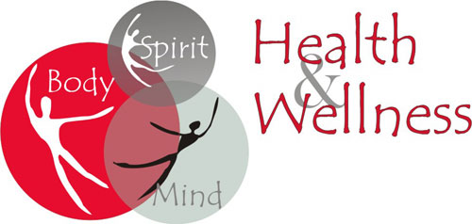
Unified Fitness Day
Hosted by Johnson County Special Olympics
Thursday March 8, 2018
From: 6:30pm to 8pm
Mount Pleasant Christian Church Life Center
381 North Bluff Road
Greenwood, In 46142
We are offering: Workout Stations, Speaker, Walking and Making New Friends
Each person will get a Free Goody Gift
RSVP by: February 21, 2018
Please send one response from the leader of the Fitness Club for each county and how many people are attending.
My email: nastya_helmich@yahoo.com
Or you can call @ 317-840-3455

